Writing 9 - Design a new school campus of our school.
Name: Hilary Tai (24) Class: J.1 Honesty

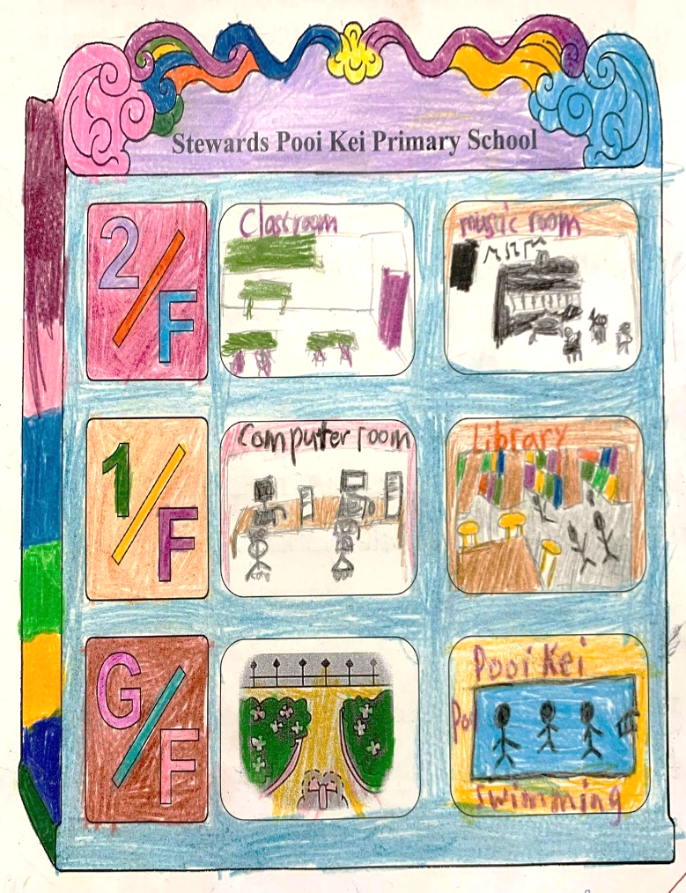

The swimming pool is on the ground floor. I can go swimming for two hours and I will feel cool. I like swimming with my friends and Miss Chang.

The library is on the first floor. I can go to the library to borrow some books. I like reading books with my friends and my teacher in the library.

The computer room is on the first floor. I can use the computer to surf the net and find useful information. I also use the computer to read ebooks and draw pictures.

The music room is on the second floor. I can use the music room to sing and play musical instruments. I like playing musical instruments with my friends.

